Set up Ec2 Instance – Select Ubuntu as your AMI and OS.
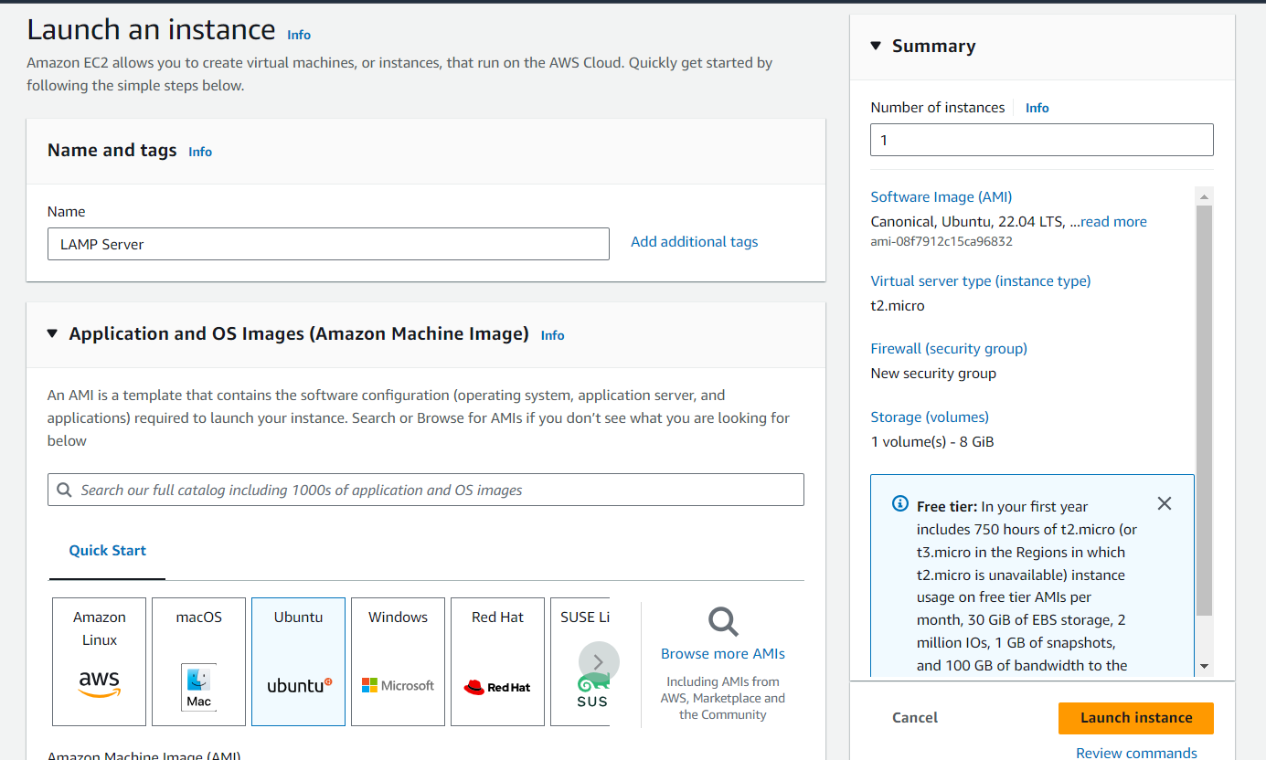

Connect to EC2 using SSH – using MobaXterm

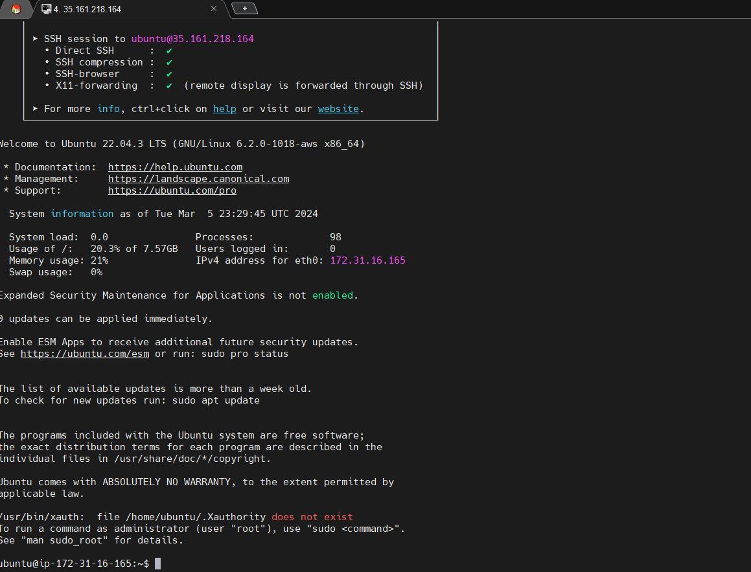

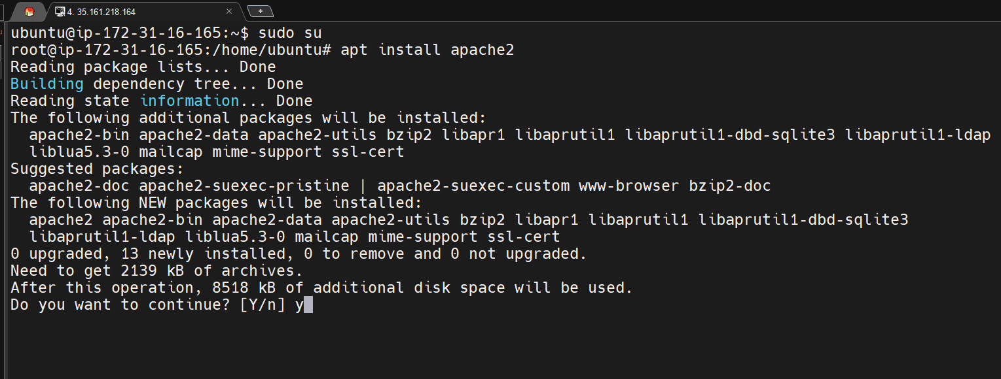
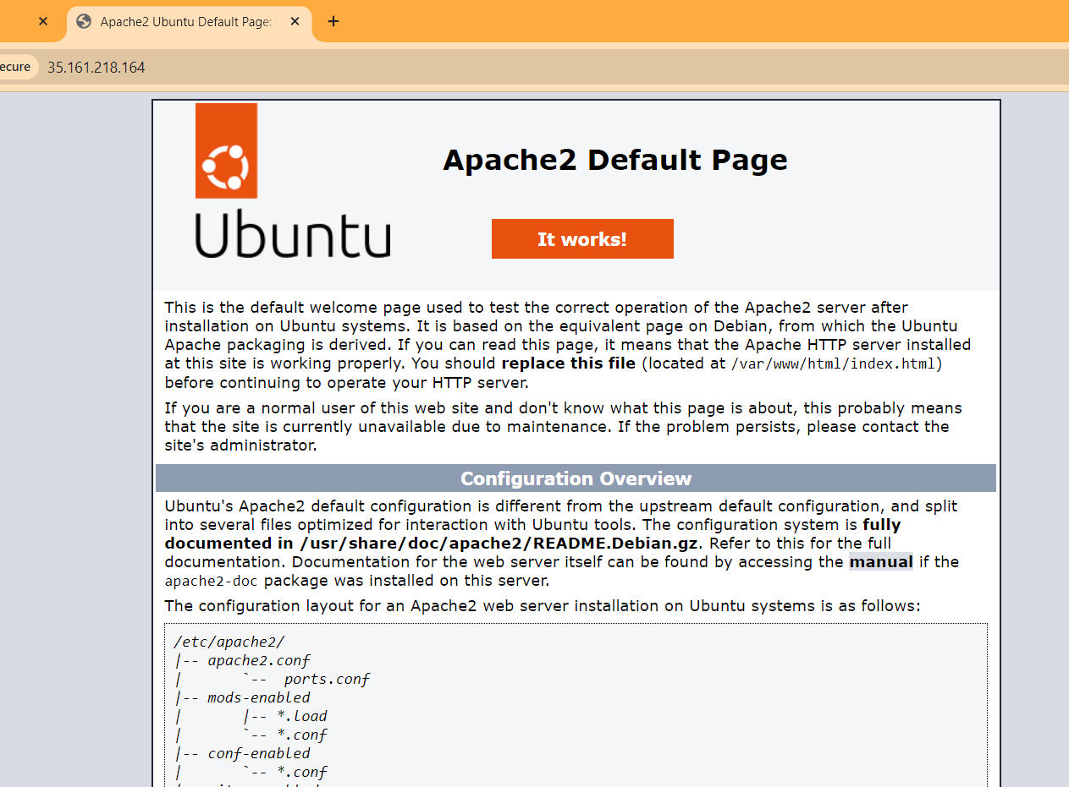
Install Apache on the Server
sudo apt install apache2
Apache Successfully Installed – Confirmation
Install MYSQL and PHP Packages
sudo apt install mysql-client-core-8.0
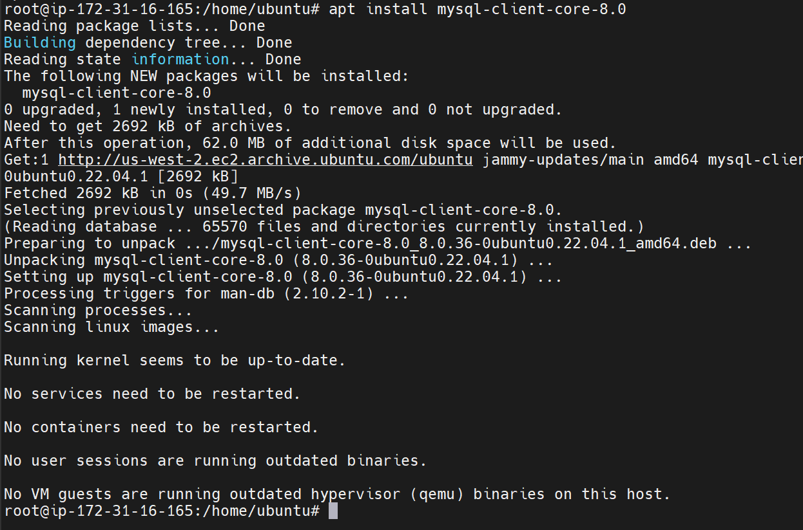

Installing PHP – sudo apt install php
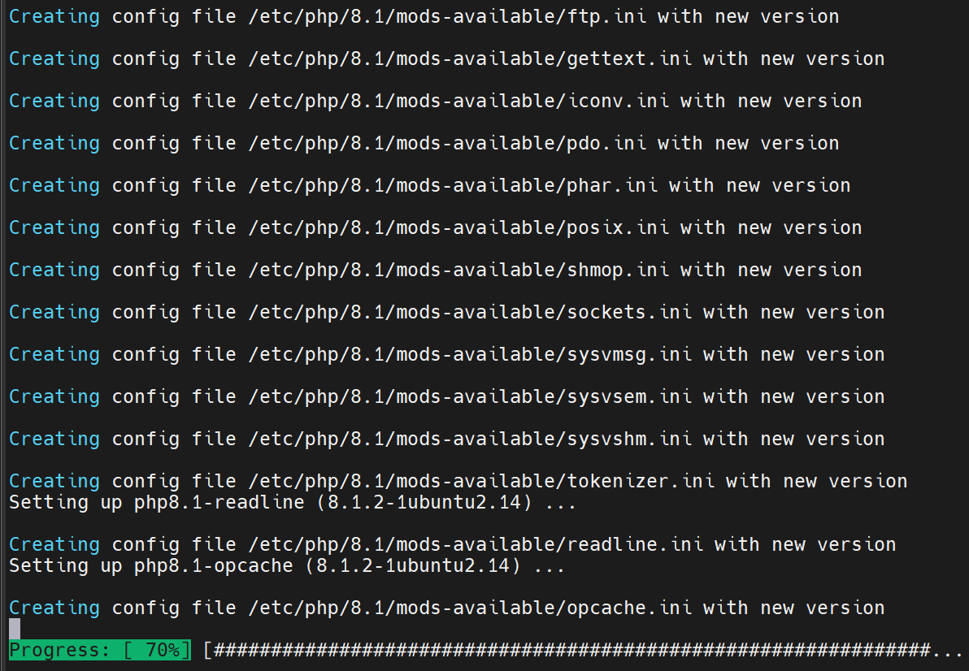
Confirm Installation of MYSQL and PHP Running on Server
sudo systemctl status mysql
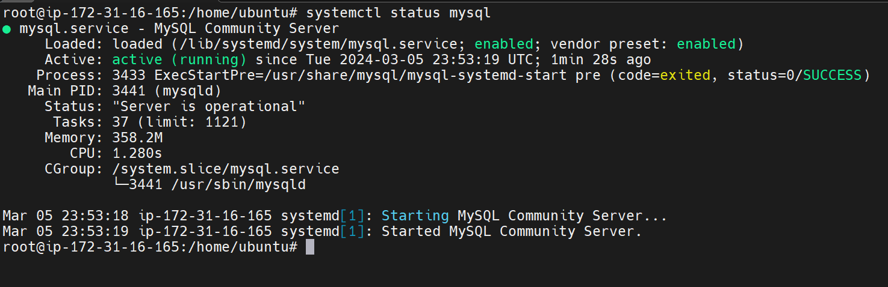php --version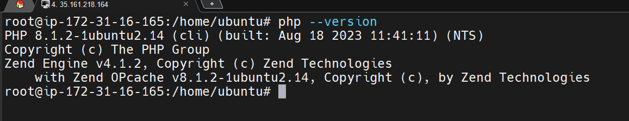
Test LAMP Stack
Creating php info file – info.php
